IEEE JOURNAL OF
BIOMEDICAL AND HEALTH INFORMATICS

J-BHI Special Issue on “A Secured and Privacy-preserved Smart Health Monitoring and Improvement System”

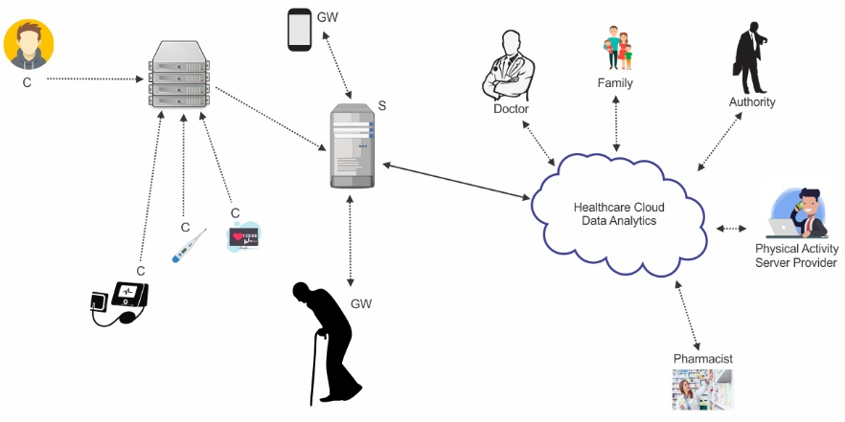
The rapid growth of smart healthcare applications is made possible by the advancements in the Internet of Things (IoT). The IoT growth is extremely fast due to connection of smart devices to the Internet. These devices collect data related to healthcare, public safety, energy, and behavior monitoring that provides useful information for a wide variety of applications. For example, in a smart health monitoring and improvement (SHAMI) system, the digital medical images are efficiently used for medical reports generation. In SHAMI system, healthcare professionals share medical data of patients for better and quick diagnosis of a disease. They use communication technology for sending the electronic medical record (EMR) because it is efficient and cost effective. However, sending EMR and medical reports on open wireless channels has high security and privacy risks. The integrity of EMR and medical reports is necessary because the modified, altered or corrupted medical data can make wrong diagnoses and create serious health issues for any individual. In addition, privacy leakage and medical identity theft is a growing concern and has contributed to a large number of e-fraud cases across the world. Therefore, in this special issue, we aim to focus on the security and privacy of medical data and reports in a smart healthcare application. This special issue will cover novel research approaches of security and privacy of medical data in a smart health application.
C is Client
S is Server
GW is Gateway

The objective of this special issue is to attract high-quality research and survey articles that promote research and reflect the most recent advances in addressing the security and privacy issues of the medical data for smart healthcare applications. We welcome researchers from both academia and industry to provide their state-of-the-art technologies and ideas covering all aspects of security and privacy solutions for the applications. Topics of interest include but are not limited to the following:
- Security and Privacy issues in smart healthcare applications
- Security and Privacy issues in AI-based healthcare application
- Security and Privacy issues in EMR and data in smart healthcare applications
- Security and Privacy issues in multimedia data analytics in smart healthcare applications
- Security and Privacy issues in IoT-enabled healthcare applications
- Cryptographic algorithm/protocols for healthcare applications
- Protection systems against person identity theft in healthcare applications
- Media cloud applications for healthcare applications
- Cyber Security for healthcare applications
- Blockchain for medical record in healthcare applications.

Guest Editors
- Dr Fazlullah Khan, RoZetta Institute Sydney, Australia, fazlullah@ieee.org
- Dr. Houbing Song, Embry-Riddle Aeronautical University, Daytona Beach, FL, USA, h.song@ieee.org
- Dr. Mian Ahmad Jan, Abdul Wali Khan University Mardan, KPK, Pakistan, mianjan@awkum.edu.pk
- Dr. Mohamed Elhoseny,, American University in the Emirates, Dubai, UAE, mohamed.elhoseny@aue.ae

Key Dates
- Submission deadline: April 30th, 2021
- First reviews due: June 30th, 2021
- Revised manuscript due: July 31st, 2021
- Final decision: August 30th, 2021
- Camera ready version: September 30th, 2021

